

**ITS30305**

**Web Programming**

Assignment 1

**HAND OUT DATE: 24th October 2017**

**HAND IN DATE: 8th November 2017**

**WEIGHTAGE: 15%**

|  |  |
| --- | --- |
| **Student declaration:** | |
| ***I declare that:***   1. ***I understand what is meant by plagiarism*** 2. ***The implication of plagiarism have been explained to us by our lecturer***   ***This project is all our work and I have acknowledged any use of the published or unpublished works of other people.*** | |
| **Name:** Aakash Suppiah a/l Manogran | **Student ID:** 0331660 |
| **Title:** Legion Dairy Farm Website | **Intake:** March 2017 |

# Contents

Contents 2

Introduction 3

Purpose and Goal for the website 3

Target Audience 5

Website Design 6

Site Map 7

Story Board 8

Appendix 11

Screen Captures 11

Source Code 19

References 35

# Introduction

# Purpose and Goal for the website

The website that I have chosen to develop was an information- disseminating website for a fictional established company which wholesales dairy product called Legion Dairy Farm. The primary goal for this website would be to provide all the necessary information about the Dairy Farm as well as in depth information about the products sold there, promoting it products to the masses to encourage them to go to their local retail shop and purchase a bottle today.

Among the examples of the information available at the website include a complete product listing of all the product the Dairy Farm produces and sells, an information page reciting the rich history of the Dairy Farm, a feedback form filled with reviews and testimonials from former customers as well as a form to provide your own feedback and finally a form page where users and register to work with our company.

In order to complete this task, I have created 5 separate html pages entitled *index.html*, *DairyProduct.html*, *DairyHistory.html*, *DairyFeedback.html* *and DairyJoin.html*.

*index.html* serves as a home and landing page as well as the main page for the entire website. Thus, it is not jam-packed with words and information, rather, it is filled with pictures and a summary about us to give a good initial impression.

*DairyProduct.html* serve as a webpage purely dedicated to list and display all of the dairy products sold by Legion Dairy Farm. In this page, all the products are neatly arranged in a tabular format. Each product is also given a detailed description and accompanied with a picture of the product at hand.

*DairyFeedback.html* enables customer to not only read reviews and testimonials from other users, it also allows user to send their own feedback about our company and our products by filling up a form.

*DairyJoin.html* is a platform for the website to recruit potential workers. In this webpage, we give a brief explanation on the potential benefits one may receive by join our company. If they are interested, they can feel up a form where they can state there desired position as well as desired wage.

Finally, I also created an external CSS styling page called *LDF STYLE.css* to accommodate styling which are similar in all of the 5 webpages.

# Target Audience

My website has been designed to specifically target multiple group of audience, the primary being potential customers who are already working and are interested in buying only the finest and highest quality diary goods. This website has been designed to give a good shock or “WOW” factor for first time customers. The website was styled to have a sleek design and professional look. This is to help give new customers an impression that the Legion Dairy Farm is a established dairy company with years of history.

By showing off how rich the history of the company, user will be more tempted to trust Legion Dairy Farm and would lull them into a sense of security. User who trust the company are more likely to actually purchase something.

All in all, the main idea for this website is to gain and attract customers and convince them on how superior our dairy product really is compared with other dairy product.

Furthermore, the website also targets youths with little to no previous job experience. This is help attract job applicants and to recruit more staff for the company.

# Website Design

The website incorporates a modern yet classic black and white look. Everything in the website including images and text are grayscaled to achieve this black and white look.

The reason I chose to stick with the classic black and white look was to shows the website’s potential viewers on how we as a company value and treasure our history yet we also embrace the future and all the mysteries that comes with it. I also wanted to show on how we as a company value our customers and thus would only serve them the finest products.

The website also rely a lot of images rather than text as I believe a beautiful pictures tell more of a story than a block of boring text.

At the start of each page, the user is greeted by a picture of a rustic barn which aim to evoke emotions in the user.

Under the parallax image, I have inserted a quote which is related to that webpage itself to give it some personality.

Most of the are located below the parallax image and quote, and are mostly arranged in a tabular format.

# Site Map

# Story Board

index.html

DairyProduct.html

DairyHistory.html

DairyFeedback.html

DairyJoin.html

# Appendix

# Screen Captures

index.html

An old barn in front of a house

Description generated with very high confidence

A screenshot of a social media post

Description generated with very high confidence

A screenshot of a social media post

Description generated with very high confidence

DairyProduct.html

An old barn in front of a house

Description generated with very high confidence

A screenshot of a social media post

Description generated with very high confidence

A screenshot of a social media post

Description generated with very high confidence

DairyHistory.html

An old barn in front of a house

Description generated with very high confidence

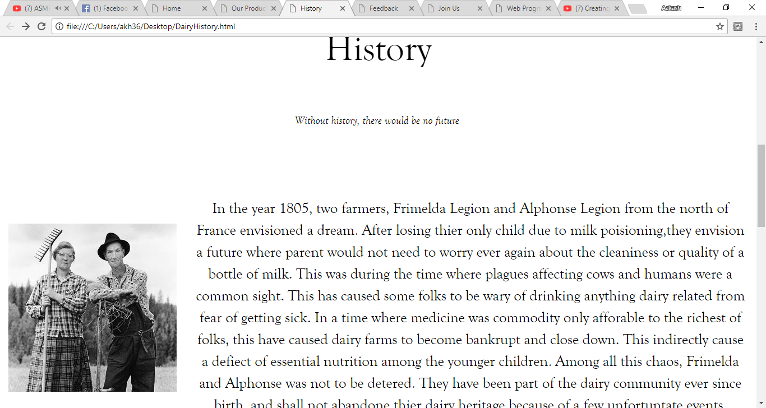

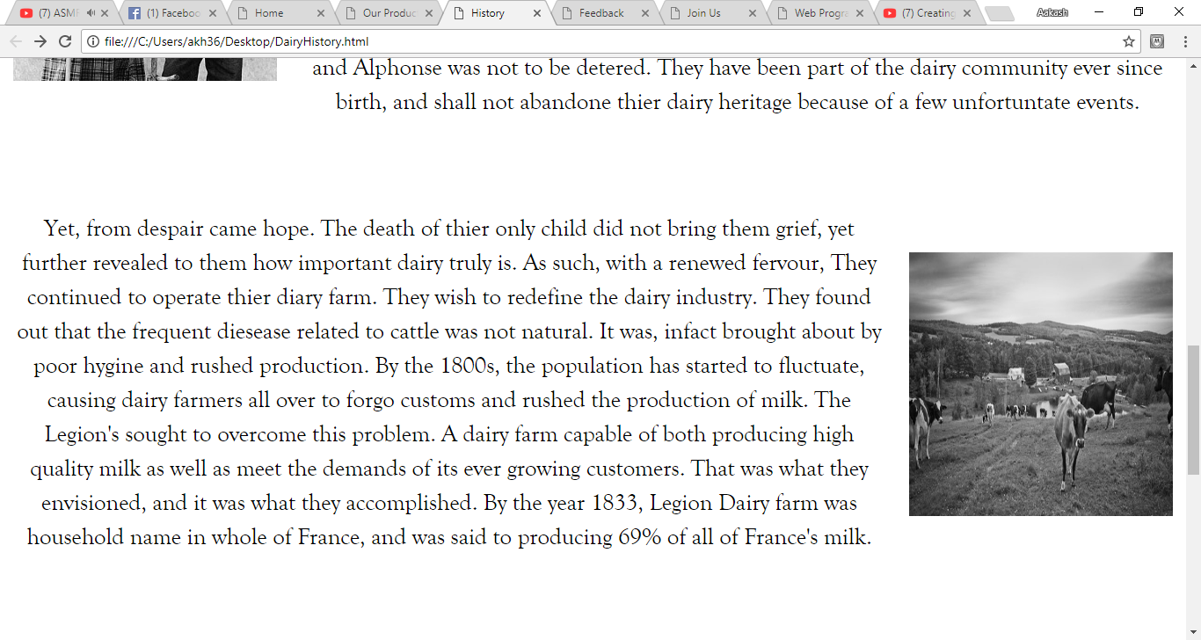

A screenshot of a social media post

Description generated with very high confidence

A picture containing screenshot

Description generated with very high confidence

DairyFeedback.html

An old barn in front of a house

Description generated with very high confidence

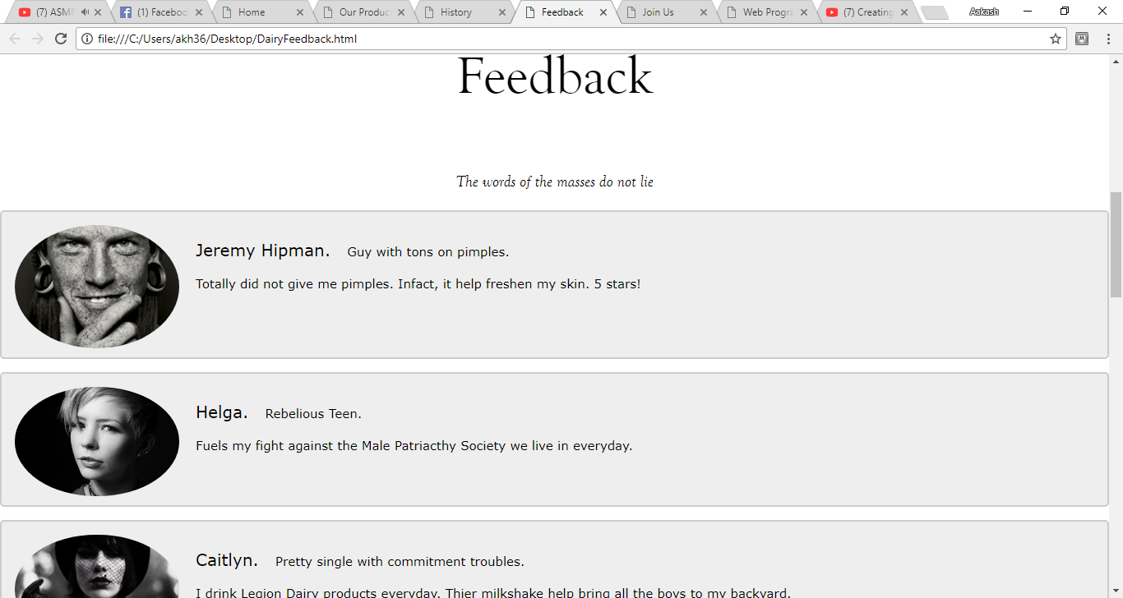

A screenshot of a cell phone

Description generated with very high confidence

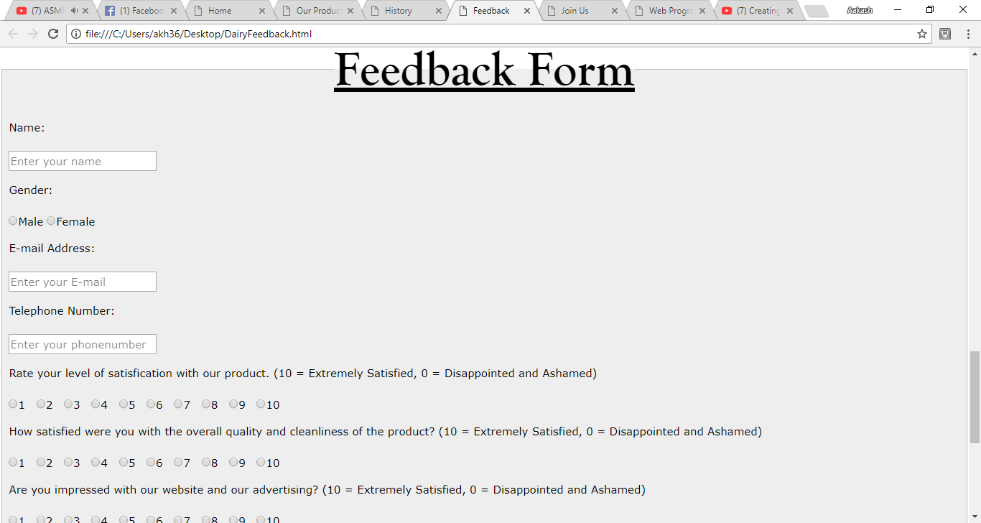

A screenshot of a cell phone

Description generated with very high confidence

DairyJoin.html

An old barn in front of a house

Description generated with very high confidence

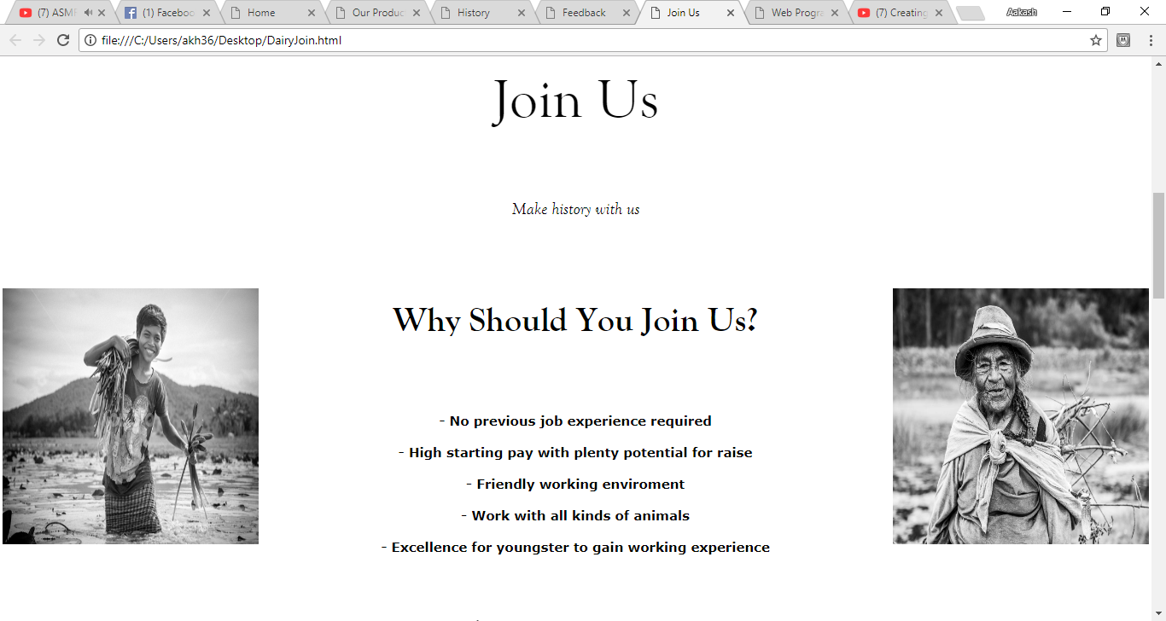

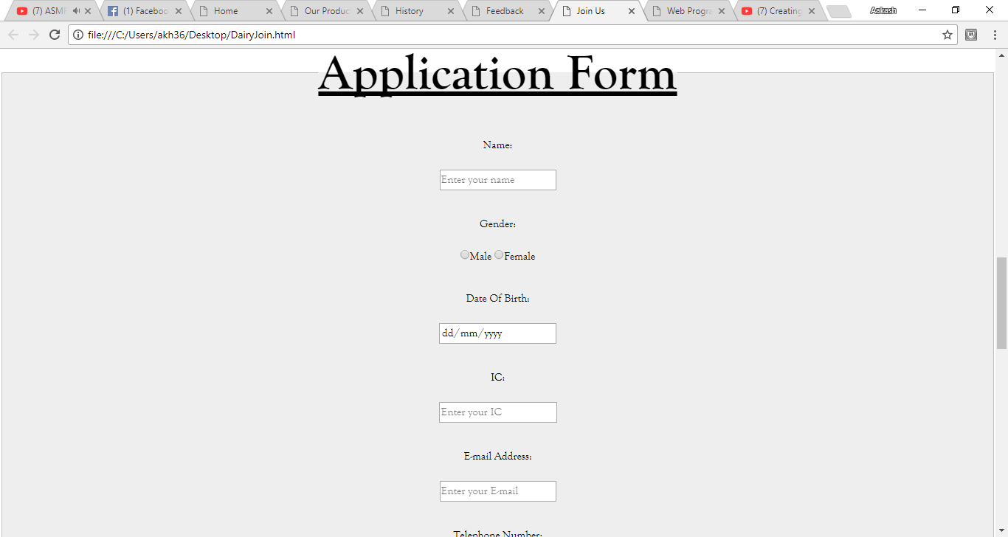

A screenshot of a cell phone

Description generated with very high confidence

A screenshot of a social media post

Description generated with very high confidence

# Source Code

index.html

<!DOCTYPE HTML>

<html>

<head>

<title> Home </title>

<meta charset="UTF-8">

<meta name="viewport" content="width=device-width, initial-scale=1">

<link rel="stylesheet" href="https://www.w3schools.com/w3css/4/w3.css">

<link rel="stylesheet" href="C:\Users\akh36\Desktop\LDF STYLE.css">

</head>

<style>

body {margin:0;}

.active {

background-color: #FFFFFF

}

.parallax {

background-image : url("https://images.fineartamerica.com/images-medium-large-5/caseys-barn-black-and-white-thomas-schoeller.jpg");

min-height: 700px;

background-attachment: fixed;

background-position: center;

background-repeat: no-repeat;

background-size: cover;

}

.container {

position: relative;

text-align: center;

color: white;

}

.centered {

position: absolute;

top: 50%;

left: 50%;

transform: translate(-50%, -50%);

}

article {

background-color: gray;

}

* {

box-sizing: border-box;

}

.column {

float: left;

width: 25%;

padding: 10px;

}

.column img {

margin-top: 12px;

}

.row :after {

content: "";

display: table;

clear: both;

}

@media (max-width: 800px) {

.column {

width : 50%;

}

}

@media (max-width: 600px) {

.column {

width: 100%;

}

}

#copyright{

background-color:black ;

color:white;

padding:10px;

text-align:center;

font-size:12pt;

}

</style>

<body>

<ul>

<li><a href="Home.html">Home</a></li>

<li><a href="Our Product">Our Product</a></li>

<li><a href="History">History</a></li>

<li><a href="Feedback">Feedback</a></li>

<li style="float:right"><a href="Join">Join Us</a></li>

</li>

<div class="parallax"></div>

<div style="height:1px;background-color:white;font-size:36px">

</div>

<div class="w3-display-middle" style="white-space:nowrap;">

<span class="w3-center w3-padding-large w3-black w3-xlarge w3-wide w3-animate-opacity">LEGION <span class="w3-hide-small">DAIRY</span> FARM</span>

</div>

<p style="text-align:center; font-size:65px; font-family:Goudy Old Style"> Legion Dairy Farm

<p style="text-align:center;font-size:20px; font-family:Goudy Old Style;"> <i>Where tradition meets quality </i>

<div class="row">

<div class="column">

<img src="" style="width:100%">

<img src="https://i.pinimg.com/236x/c1/d9/fc/c1d9fcfdeda9d5531399159f30cc2faa--moo-cattle.jpg" style="width:100%">

<img src="http://www.pxleyes.com/images/contests/cheese-and-wine/fullsize/Bittersweet-symphony----4e08a10f7e582_hires.jpg" style="width:100%">

</div>

<div class="column">

<img src="https://flashbak.com/wp-content/uploads/2016/04/Three-farmers-swig-bottles-of-Old-Milwaukee-lager-1941.jpeg" style="width:100%">

<img src="https://img1.etsystatic.com/106/0/6725214/il_340x270.913939051_3cd0.jpg" style="width:100%">

</div>

<div class="column">

<img src="https://ih1.redbubble.net/image.14465887.7759/flat,550x550,075,f.u5.jpg" style="width:100%">

<img src="https://images.fineartamerica.com/images-medium-large-5/cow-bob-orsillo.jpg" style="width:100%">

</div>

<div class="column">

<img src="https://ssl.c.photoshelter.com/img-get2/I0000bp_mL385V6g/fit=1000x750/Michael-Kloth-Inside-a-Barn-in-Kentucky-MG-1447.jpg" style="width:100%">

<img src="https://photoplacegallery.com/wp-content/uploads/2015/04/Butler_David_Catalet-Cheese-BW-Contest.jpg" style="width:100%">

</div>

</div>

<p> *

<br> <br> <br> <br>

<article>

<h1 style="text-align:center; font-family:Goudy Old Style; font-size:40px;"> About Us

<p style=" font-family:Goudy Old Style; font-size:20px;"> Founded in the late 1800's by a couple of goodhearted dairy farmers, Legion Dairy Farm has been a staple in the dairy business in Europe and has been satisying customers for more then two centuries. Born form a vision to only provide

the highest quality milk and dairy products to its customers, Legion Dairy Farm has kept true to its humble origins and now is one of the industry leaders in all things dairy related. All dairy products from Legion Dairy Farm are guaranteed

to be the freshes and the most nutritious dairy product money can buy. Visit your local retail shop now to purchase a bottle of goodness today!

<p id="copyright">Copyright &copy; 2017 All Rights Reserved to Legion Dairy Farm Inc | Developed By <a href="https://www.facebook.com/aakash.suppiah" target="_blank"><b>Company Supreme Head of Chief Aakash Suppiah </b></a></p>

</body>

</html>

DairyProduct.html

<!DOCTYPE HTML>

<html>

<head>

<title> Our Products </title>

<meta charset="UTF-8">

<meta name="viewport" content="width=device-width, initial-scale=1">

<link rel="stylesheet" href="https://www.w3schools.com/w3css/4/w3.css">

<link rel="stylesheet" href="C:\Users\akh36\Desktop\LDF STYLE.css">

</head>

<style>

table,th,td{

border: 2px solid black;

}

table{

margin-left: auto;

margin-right: auto;

background-color: black;

}

th,td{

padding:10pt;

text-align: center;

}

td{

background-color: white;

font-size:15pt;

font-family: Goudy Old Style;

}

th{

background-color: white;

font-weight: bold;

font-size: 15pt;

font-family: Goudy Old Style;

}

img {

-webkit-filter: grayscale(100%);

filter: grayscale(100%);

}

</style>

<body>

<ul>

<li><a href="Home.html">Home</a></li>

<li><a href="Our Product">Our Product</a></li>

<li><a href="History">History</a></li>

<li><a href="Feedback">Feedback</a></li>

<li style="float:right"><a href="Order">Order Now</a></li>

</li>

<div class="parallax"></div>

<div style="height:1px;background-color:white;font-size:36px">

</div>

<div class="w3-display-middle" style="white-space:nowrap;">

<span class="w3-center w3-padding-large w3-black w3-xlarge w3-wide w3-animate-opacity">LEGION <span class="w3-hide-small">DAIRY</span> FARM</span>

</div>

<p style="text-align:center; font-size:65px; font-family:Goudy Old Style"> Our Products

<p style="text-align:center;font-size:20px; font-family:Goudy Old Style;"> <i>Sample the finest money can accquire... </i>

<br>

<table width="95%">

<th>Item</th>

<th>Description</th>

<th>Picture</th>

</tr>

<tr>

<td>Cow Milk</td>

<td>Milked from the utters of a fully mature and healthy cow, our cow's milk are internationally graded as grade "S" by the Europeon Food Communites. The milk is pasteurized at an exact temperature where are the harmful bacteria are killed while all the nutrition remains. </td>

<td ><img src="https://www.wellesley.edu/sites/default/files/assets/dailyshot/ds_wellesleymag.jpg" width="200px" height="120px" alt="Cow Milk" title="Cow Milk"></td>

</tr>

<tr>

<td> Cheese </td>

<td> Formed by the coagulation of the milk of one of our own specially bred cows, our cheese are prepared the same exact way our founders did more then two centuries ago. This has allowed our cheese to be among one the most flavourful cheese in the world. No checimals or artifical ingredients added, only the most natural and organic ingredients are used.</td>

<td><img src="http://4.bp.blogspot.com/-EGa_wJ3z6HQ/Tc_MTpO9qtI/AAAAAAAAACQ/_fjnRpC7tWI/s1600/Header.jpg" width="200px" height="120px" alt="Cheese" title=" Cheese"></td>

</tr>

<tr>

<td>Butter</td>

<td> Our Butter are made by churning fresh cow's milk to seperate the buttermilk. Unlike most modern dairy companies, we do not use clunky machines, rather we rely on human manpower as we think that each and every roll of butter we produce is unique in its own special way. Our butter contains an exact 80% of butterfat with no artifical ingredients </td>

<td ><img src="http://cdn.thankyourbody.com/wp-content/uploads/2016/05/Butter-Healthy-Featured.png" width="200px" height="120px" alt="Cheese" title="Butter"></td>

</tr>

<tr>

<td>Ice Cream</td>

<td>An absolute frozen delight. Give your taste buds a treat with our newly launched ice cream made by using only the finest cow's milk and frozen to an absolute chilling temperature. No additional sugar or artifical flavouring added, yet every bit as sweet and nutritious. </td>

<td ><img src="https://cdn.pixabay.com/photo/2014/07/31/21/22/ice-cream-406827__340.jpg" width="200px" height="120px" alt="Ice Cream" title="Ice Cream"></td>

</tr>

<tr>

<td>Yogurt</td>

<td> Produced in an controlled enviroment where high quality milk undergoes bacterial fermentation, our yougurt has been expertly crafted to be sour yet ever so sweet. Not to mention the high nutritious content of our yougurt, only a fool would pass down a bowl of one of our own Legion Yogurt. </td>

<td ><img src="https://us.123rf.com/450wm/chechotkin/chechotkin1602/chechotkin160200096/53678750-black-and-white-yogurt-view-from-above.jpg?ver=6" width="200px" height="120px" alt="Yogurt" title="Yogurt"></td>

</tr>

<tr>

<td>Sour Cream</td>

<td> Enjoy even the simplest of treats with our newly lanched sour cream. Our sour cream is the prefect blend of sourness and creaminess that it can make any food instantly much better. It taste mild and does not overpower the original taste of a food, yet simply enchances it with its sour goodness. Enjoy it with biscuits, bread and even rice. </td>

<td ><img src="https://static.pexels.com/photos/74719/abstract-white-cream-74719.jpeg" width="200px" height="120px" alt="Sour Cream" title="Sour Cream"></td>

</tr>

</table>

<br>

<p id="copyright">Copyright &copy; 2017 All Rights Reserved to Legion Dairy Farm Inc | Developed By <a href="https://www.facebook.com/aakash.suppiah" target="_blank"><b>Company Supreme Head of Chief Aakash Suppiah </b></a></p>

</body>

</html>

DairyHistory.html

<!DOCTYPE HTML>

<html>

<head>

<title> History </title>

<meta charset="UTF-8">

<meta name="viewport" content="width=device-width, initial-scale=1">

<link rel="stylesheet" href="https://www.w3schools.com/w3css/4/w3.css">

<link rel="stylesheet" href="C:\Users\akh36\Desktop\LDF STYLE.css">

</head>

<style>

p {

font-family:Goudy Old Style;

font-size: 20pt;

}

th,td{

padding:10pt;

text-align: center;

font-family:Goudy Old Style;

font-size: 20pt;

}

table{

margin-left: auto;

margin-right: auto;

}

article {

background-color: gray;

}

* {

box-sizing: border-box;

}

</style>

<body>

<ul>

<li><a href="Home.html">Home</a></li>

<li><a href="Our Product">Our Product</a></li>

<li><a href="History">History</a></li>

<li><a href="Feedback">Feedback</a></li>

<li style="float:right"><a href="Join">Join Us</a></li>

</li>

<div class="parallax"></div>

<div style="height:1px;background-color:white;font-size:36px">

</div>

<div class="w3-display-middle" style="white-space:nowrap;">

<span class="w3-center w3-padding-large w3-black w3-xlarge w3-wide w3-animate-opacity">LEGION <span class="w3-hide-small">DAIRY</span> FARM</span>

</div>

<p style="text-align:center; font-size:65px; font-family:Goudy Old Style"> History

<p style="text-align:center;font-size:20px; font-family:Goudy Old Style;"> <i> Without history, there would be no future </i> <br> <br> <br>

<table>

<td><img src="http://www.culture24.org.uk/asset_arena/6/32/96/369236/v0_master.jpg" style="float:left;width:300px;height:300px;">

<td><p > In the year 1805, two farmers, Frimelda Legion and Alphonse Legion from the north of France envisioned a dream. After losing thier only child due to milk poisioning,they envision a future where parent would not need to worry ever again

about the cleaniness or quality of a bottle of milk. This was during the time where plagues affecting cows and humans were a common sight. This has caused some folks to be wary of drinking anything dairy related from fear of

getting sick. In a time where medicine was commodity only afforable to the richest of folks, this have caused dairy farms to become bankrupt and close down. This indirectly cause a defiect of essential nutrition among the younger children.

Among all this chaos, Frimelda and Alphonse was not to be detered. They have been part of the dairy community ever since birth, and shall not abandone thier dairy heritage because of a few unfortuntate events.</table>

<br>

<table>

<td><p > Yet, from despair came hope. The death of thier only child did not bring them grief, yet further revealed to them how important dairy truly is. As such, with a renewed fervour, They continued to operate thier diary farm. They wish to redefine the dairy industry. They found out that the frequent diesease related to cattle was not natural. It was, infact brought about by poor hygine and rushed production. By the 1800s, the population has

started to fluctuate, causing dairy farmers all over to forgo customs and rushed the production of milk. The Legion's sought to overcome this problem. A dairy farm capable of both producing high quality milk as well as meet the demands of its

ever growing customers. That was what they envisioned, and it was what they accomplished. By the year 1833, Legion Dairy farm was household name in whole of France, and was said to producing 69% of all of France's milk.

<td><img src="https://newengland.com/wp-content/uploads/legacy_cms_images/9121.jpg" style="float:right;width:300px;height:300px;"> </table> <br>

<table>

<td><img src="https://i.pinimg.com/736x/c1/f5/db/c1f5db0a04ff49ee6ca2964ff607be58--the-urban-farmhouse-industrial-farmhouse.jpg" style="float:left;width:300px;height:350px;">

<td><p > In the year 1869, after the death of the Legions due to an unforunate accident, a billionaire named Aakash Suppiah managed to accquire the rights to Legion Dairy Farm. Thanks to him and his descendents, they managed to not only stay true to the ways of Frimelda and Alphonse, they also improved in every way possible and make Legion Dairy a world famous product. Today, Legion Dairy Farm can be found around the globe in over 39 different

countries, yet no matter the region, one can expect the same quality and freshness with ever bottle of Legion Dairy milk and any of it other dairy product. We use a blend and modern and traditional ways to create our world famous dairy product, as well as to keep true to the ways Alphonse and Frimelda envisioned for their company.</table>

<br>

<article>

<h1 style="text-align:center; font-family:Goudy Old Style; font-size:40px;"> Learn More About Us!

<p style="text-align:center; font-family:Goudy Old Style; font-size:20px;"> <i> Visit this link and read up to know all things dairy related </i>

<p style=" font-family:Goudy Old Style; font-size:20px;"> Cattle -----> <a href="https://en.wikipedia.org/wiki/Cattle" target="_blank"> Click Me(Wikipedia)

<p style=" font-family:Goudy Old Style; font-size:20px;"> Dairy -----> <a href="https://en.wikipedia.org/wiki/Dairy" target="_blank"> Click Me(Wikipedia)

<p style=" font-family:Goudy Old Style; font-size:20px;"> Dairy Farming -----> <a href="https://en.wikipedia.org/wiki/Dairy_farming" target="_blank"> Click Me(Wikipedia)

<br>

<p id="copyright">Copyright &copy; 2017 All Rights Reserved to Legion Dairy Farm Inc | Developed By <a href="https://www.facebook.com/aakash.suppiah" target="_blank"><b>Company Supreme Head of Chief Aakash Suppiah </b></a></p>

</body>

</html>

DairyFeedback.html

<!DOCTYPE HTML>

<html>

<head>

<title> Feedback </title>

<meta charset="UTF-8">

<meta name="viewport" content="width=device-width, initial-scale=1">

<link rel="stylesheet" href="https://www.w3schools.com/w3css/4/w3.css">

<link rel="stylesheet" href="C:\Users\akh36\Desktop\LDF STYLE.css">

</head>

<style>

.containerr {

border: 2px solid #ccc;

background-color: #eee;

border-radius: 5px;

padding: 16px;

margin: 16px 0

}

.containerr::after {

content: "";

clear: both;

display: table;

}

.containerr img {

float: left;

margin-right: 20px;

border-radius: 50%;

}

.containerr span {

font-size: 20px;

margin-right: 15px;

}

@media (max-width: 500px) {

.containerr {

text-align: center;

}

.containerr img {

margin: auto;

float: none;

display: block;

}

}

.button {

background-color: black;

border: none;

border-radius: 8px;

color: white;

padding: 15px 32px;

text-align: center;

text-decoration: none;

display: inline-block;

font-size: 16px;

margin: 4px 2px;

cursor: pointer;

}

</style>

<body>

<ul>

<li><a href="Home.html">Home</a></li>

<li><a href="Our Product">Our Product</a></li>

<li><a href="History">History</a></li>

<li><a href="Feedback">Feedback</a></li>

<li style="float:right"><a href="Join">Join Us</a></li>

</li>

<div class="parallax"></div>

<div style="height:1px;background-color:white;font-size:36px">

</div>

<div class="w3-display-middle" style="white-space:nowrap;">

<span class="w3-center w3-padding-large w3-black w3-xlarge w3-wide w3-animate-opacity">LEGION <span class="w3-hide-small">DAIRY</span> FARM</span>

</div>

<p style="text-align:center; font-size:65px; font-family:Goudy Old Style"> Feedback

<p style="text-align:center;font-size:20px; font-family:Goudy Old Style;"> <i> The words of the masses do not lie </i>

<div class="containerr">

<img src="https://jeremyparkphotographer.files.wordpress.com/2010/11/jeremy-black-white-portrait052.jpg" alt="Avatar" style="width:200px">

<p><span>Jeremy Hipman.</span> Guy with tons on pimples.</p>

<p>Totally did not give me pimples. Infact, it help freshen my skin. 5 stars!</p>

</div>

<div class="containerr">

<img src="https://digital-photography-school.com/wp-content/uploads/2015/08/black-and-white-portrait-tips-3201.jpg" alt="Avatar" style="width:200px">

<p><span >Helga.</span> Rebelious Teen.</p>

<p> Fuels my fight against the Male Patriacthy Society we live in everyday. </p>

</div>

<div class="containerr">

<img src="https://assets.hongkiat.com/uploads/black-white-portraits/funeral.jpg" alt="Avatar" style="width:200px">

<p><span >Caitlyn.</span> Pretty single with commitment troubles.</p>

<p> I drink Legion Dairy products everyday. Thier milkshake help bring all the boys to my backyard. </p>

</div>

<div class="containerr">

<img src="https://ssl.c.photoshelter.com/img-get2/I0000m86Cyu_Vmz4/fit=1000x750/Camel-Man-Black-White-Portrait.jpg" alt="Avatar" style="width:200px">

<p><span >Ali and his camel Abu.</span> Camel man <p>

<p> My camel loves to drink Legion Dairy milk everyday! Sometimes, he even shares it with me. </p>

</div>

<div class="containerr">

<img src="https://iso.500px.com/wp-content/uploads/2015/06/bwportraits_cover.jpeg" alt="Avatar" style="width:200px">

<p><span >Paul Bulcke.</span> CEO at Nestlé <p>

<p> Ran my company Nestlé out of business. Thier milk is pretty good tho. </p>

</div>

<p style="text-align:center; font-size:45px; font-family:Goudy Old Style"> Wish to say something?

<p style="text-align:center;font-size:15px; font-family:Goudy Old Style;"> <i> Feel up our feedback form and tell us how can we improve! </i>

<form method="post">

<fieldset style="background-color:#eee">

<legend style="font-size:50pt; font-weight:bold; font-family:Goudy Old Style; text-align:center;"><u><b>Feedback Form</b></u></legend>

<p>Name:<br><br> <input type="text" name="name" placeholder="Enter your name"> </p>

<p>Gender:<br><br>

<input type="radio" name="gender" value="male">Male

<input type="radio" name="gender" value="female">Female</p>

<p >E-mail Address:<br><br>

<input type="email" name="email" placeholder="Enter your E-mail" required></p>

<p>Telephone Number:<br><br>

<input type="tel" name="telNum" placeholder="Enter your phonenumber" required></p>

<p>Rate your level of satisfication with our product. (10 = Extremely Satisfied, 0 = Disappointed and Ashamed)<br><br>

<input type="radio" name="recommend" value="1">1 &nbsp;

<input type="radio" name="recommend" value="2">2 &nbsp;

<input type="radio" name="recommend" value="3">3 &nbsp;

<input type="radio" name="recommend" value="4">4 &nbsp;

<input type="radio" name="recommend" value="5">5 &nbsp;

<input type="radio" name="recommend" value="6">6 &nbsp;

<input type="radio" name="recommend" value="7">7 &nbsp;

<input type="radio" name="recommend" value="8">8 &nbsp;

<input type="radio" name="recommend" value="9">9 &nbsp;

<input type="radio" name="recommend" value="10">10 &nbsp; </p>

<p>How satisfied were you with the overall quality and cleanliness of the product? (10 = Extremely Satisfied, 0 = Disappointed and Ashamed)<br><br>

<input type="radio" name="recommend" value="1">1 &nbsp;

<input type="radio" name="recommend" value="2">2 &nbsp;

<input type="radio" name="recommend" value="3">3 &nbsp;

<input type="radio" name="recommend" value="4">4 &nbsp;

<input type="radio" name="recommend" value="5">5 &nbsp;

<input type="radio" name="recommend" value="6">6 &nbsp;

<input type="radio" name="recommend" value="7">7 &nbsp;

<input type="radio" name="recommend" value="8">8 &nbsp;

<input type="radio" name="recommend" value="9">9 &nbsp;

<input type="radio" name="recommend" value="10">10 &nbsp; </p>

<p>Are you impressed with our website and our advertising? (10 = Extremely Satisfied, 0 = Disappointed and Ashamed)<br><br>

<input type="radio" name="recommend" value="1">1 &nbsp;

<input type="radio" name="recommend" value="2">2 &nbsp;

<input type="radio" name="recommend" value="3">3 &nbsp;

<input type="radio" name="recommend" value="4">4 &nbsp;

<input type="radio" name="recommend" value="5">5 &nbsp;

<input type="radio" name="recommend" value="6">6 &nbsp;

<input type="radio" name="recommend" value="7">7 &nbsp;

<input type="radio" name="recommend" value="8">8 &nbsp;

<input type="radio" name="recommend" value="9">9 &nbsp;

<input type="radio" name="recommend" value="10">10 &nbsp; </p>

<p>Additonal Feedback:<br><br>

<textarea name="feedback" rows="10" cols="100">Feel free to write till your heart's content and tell us how we can improve. We assure you that we read and consider every review about us. Your thought and opinions are very important to us and we treasure them greatly.</textarea>

</p>

<button type="button" class="button" onclick="alert('Your Response Has Been Recorded. Thank You for Your Time. We hope you have enjoyed our supreme quality dairy product.')">Submit</button>&nbsp;&nbsp; <!--To submit response and display a pop-up message-->

<button type="reset" class="button">RESET</button> <!--To erase all data which has been filled up-->

</fieldset>

</form>

<p id="copyright">Copyright &copy; 2017 All Rights Reserved to Legion Dairy Farm Inc | Developed By <a href="https://www.facebook.com/aakash.suppiah" target="_blank"><b>Company Supreme Head of Chief Aakash Suppiah </b></a></p>

</body>

</html>

DairyJoin.html

<!DOCTYPE HTML>

<html>

<head>

<title> Join Us </title>

<meta charset="UTF-8">

<meta name="viewport" content="width=device-width, initial-scale=1">

<link rel="stylesheet" href="https://www.w3schools.com/w3css/4/w3.css">

<link rel="stylesheet" href="C:\Users\akh36\Desktop\LDF STYLE.css">

</head>

<style>

article {

background-color: #eee;

}

.button {

background-color: black;

border: none;

border-radius: 8px;

color: white;

padding: 15px 32px;

text-align: center;

text-decoration: none;

display: inline-block;

font-size: 16px;

margin: 4px 2px;

cursor: pointer;

}

</style>

<body>

<ul>

<li><a href="Home.html">Home</a></li>

<li><a href="Our Product">Our Product</a></li>

<li><a href="History">History</a></li>

<li><a href="Feedback">Feedback</a></li>

<li style="float:right"><a href="Join">Join Us</a></li>

</li>

<div class="parallax"></div>

<div style="height:1px;background-color:white;font-size:36px">

</div>

<div class="w3-display-middle" style="white-space:nowrap;">

<span class="w3-center w3-padding-large w3-black w3-xlarge w3-wide w3-animate-opacity">LEGION <span class="w3-hide-small">DAIRY</span> FARM</span>

</div>

<p style="text-align:center; font-size:65px; font-family:Goudy Old Style"> Join Us

<p style="text-align:center;font-size:20px; font-family:Goudy Old Style;"> <i> Make history with us </i>

<table width="100%">

<br> <th><img src="http://www.pixoto.com/images-photography/black-and-white/portraits-and-people/young-farmer-of-cambodia-4801348476338176.jpg" style="float:left;width:300px;height:300px;"></th>

<th> <p style="text-align:center; font-size:40px; font-family:Goudy Old Style"> Why Should You Join Us? </p><br>

<p> - No previous job experience required

<p> - High starting pay with plenty potential for raise

<p> - Friendly working enviroment

<p> - Work with all kinds of animals

<p> - Excellence for youngster to gain working experience </th>

<th><img src="http://www.matthewwilliams-ellis.com/wp-content/uploads/2013/12/Travel-photography-by-London-commercial-photographer-documentary-photographer-and-luxury-hotel-and-resort-photographer-Matthew-Williams-Ellis-19.jpg" style="float:right;width:300px;height:300px;"> </th>

<tr>

</table>

<br>

<h1 style="text-align:center; font-family:Goudy Old Style;">

<form method="post">

<fieldset style="background-color:#eee">

<legend style="font-size:50pt; font-weight:bold; font-family:Goudy Old Style; text-align:center;"><u><b>Application Form</b></u></legend>

<p style="font-size:15px; padding:10px;">Name:<br><br> <input type="text" name="name" placeholder="Enter your name"> </p>

<p style="font-size:15px; padding:10px;">Gender:<br><br>

<input type="radio" name="gender" value="male">Male

<input type="radio" name="gender" value="female">Female</p>

<p style="font-size:15px; padding:10px;">Date Of Birth:<br><br>

<input type="date" name="visitDate" required ></p>

<p style="font-size:15px; padding:10px;">IC:<br><br>

<input type="ic" name="telNum" placeholder="Enter your IC" required></p>

<p style="font-size:15px; padding:10px;" >E-mail Address:<br><br>

<input type="email" name="email" placeholder="Enter your E-mail" required></p>

<p style="font-size:15px; padding:10px;">Telephone Number:<br><br>

<input type="tel" name="telNum" placeholder="Enter your phonenumber" required></p>

<p style="font-size:15px; padding:10px;">Do you have previous working experience?<br><br>

<input type="radio" name="ex" value="male">Yes

<input type="radio" name="ex" value="female">No</p>

<p style="font-size:15px; padding:10px;">Are you familiar working with animals?<br><br>

<input type="radio" name="ex" value="male">Yes

<input type="radio" name="ex" value="female">No</p>

<p style="font-size:15px; padding:10px;">Do you have any allergics? If so state that allergic.<br><br>

<input type="radio" name="ex" value="male">Yes

<input type="radio" name="ex" value="female">No

<p style="font-size:15px; padding:10px;">Additonal Feedback:<br><br>

<textarea name="write" rows="4" cols="100">Please state your allergics as well as any other additional details.</textarea>

</p>

<p style="font-size:15px; padding:10px;">Preferred Position:<br><br>

<datalist id="position">

<option value="Janitor">

<option value="Rookie Milker">

<option value="Rookie Brusher">

<option value="Rookie Feeder">

<option value="Companionship">

<option value="Marketing">

<option value="Cashier">

<option value="Rookie Supplymaster">

</datalist>

<input list="position" required>

<p style="font-size:15px; padding:10px;">Preferred Wage:<br><br>

<datalist id="wage">

<option value="0 - 500">

<option value="501 - 1000">

<option value="1001 - 1500">

<option value="1501 - 2000">

<option value="2001 - 2500">

<option value="2501 - 5000">

<option value="5001 - 10000">

<option value="No Preference">

</datalist>

<input list="wage" required>

<p style="font-size:15px; padding:10px;">Tell Us About Yourself in 300 words or more:<br><br>

<textarea name="feedback" rows="10" cols="100">Write about yourself and why we should hire you.</textarea>

</p>

<button type="button" class="button" onclick="alert('Your Response Has Been Recorded. Thank You for Your Time. We hope you have enjoyed our supreme quality dairy product.')">Submit</button>&nbsp;&nbsp; <!--To submit response and display a pop-up message-->

<button type="reset" class="button">RESET</button> <!--To erase all data which has been filled up-->

</fieldset>

</form>

<p id="copyright">Copyright &copy; 2017 All Rights Reserved to Legion Dairy Farm Inc | Developed By <a href="https://www.facebook.com/aakash.suppiah" target="_blank"><b>Company Supreme Head of Chief Aakash Suppiah </b></a></p>

</body>

</html>

LDF STYLE.css

/* An External Style Sheet */

ul {

list-style-type: none;

margin: 0;

padding: 0;

overflow: hidden;

background-color: #333

position: fixed;

top: 0;

width: 100%;

}

li {

float: left;

border-right: 1px solid #bbb;

}

li a {

display: block;

color: white;

text-align: center;

padding: 15px 45px;

text-decoration: none;

}

li a:hover {

background-color: #111;

}

.active {

background-color: #FFFFFF

}

#copyright{

background-color:black ;

color:white;

padding:10px;

text-align:center;

font-size:12pt;

font-family: Goudy Old Style;

}

body {margin:0;}

.active {

background-color: #FFFFFF

}

.parallax {

background-image : url("https://images.fineartamerica.com/images-medium-large-5/caseys-barn-black-and-white-thomas-schoeller.jpg");

min-height: 700px;

background-attachment: fixed;

background-position: center;

background-repeat: no-repeat;

background-size: cover;

}

.container {

position: relative;

text-align: center;

color: white;

}

.centered {

position: absolute;

top: 50%;

left: 50%;

transform: translate(-50%, -50%);

}

# References

https://www.w3schools.com/